# Experiment No: 14

**Aim**

To familiarize with indexing in MongoDB

# CO5

Apply CRUD operations and retrieve data in a NoSQL environment.

# Procedure

* 1. Create and Use a Database



* 1. Show Databases

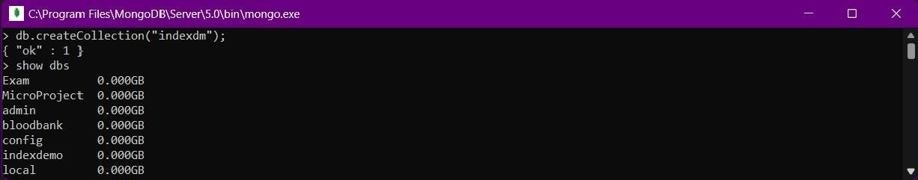

* 1. Input data

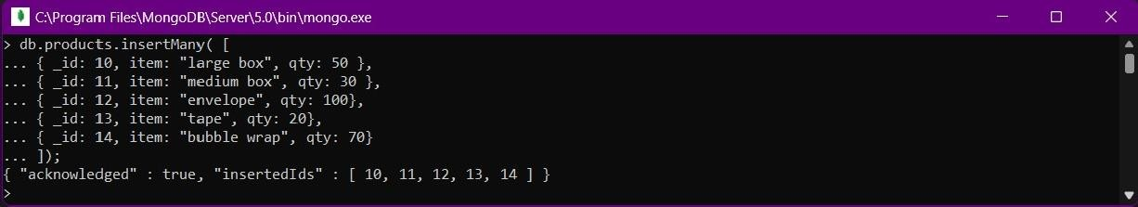

* 1. Create ascending index on a field

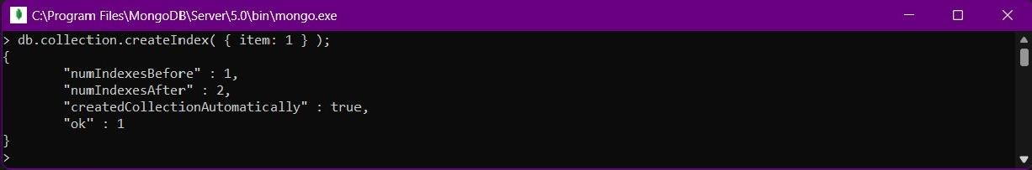

* 1. Create descending index on a field

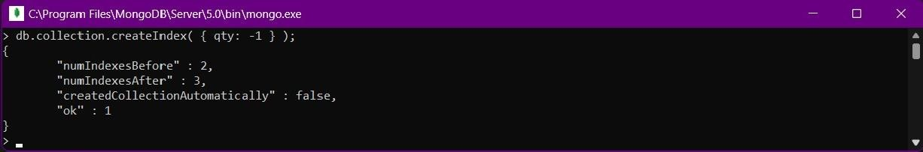

* 1. Create index with the index name

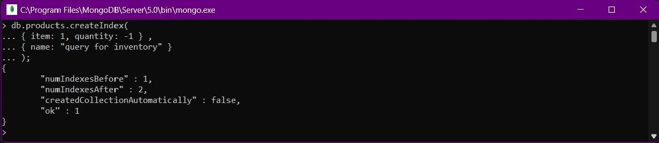

* 1. To list out indexes on the <collection>,

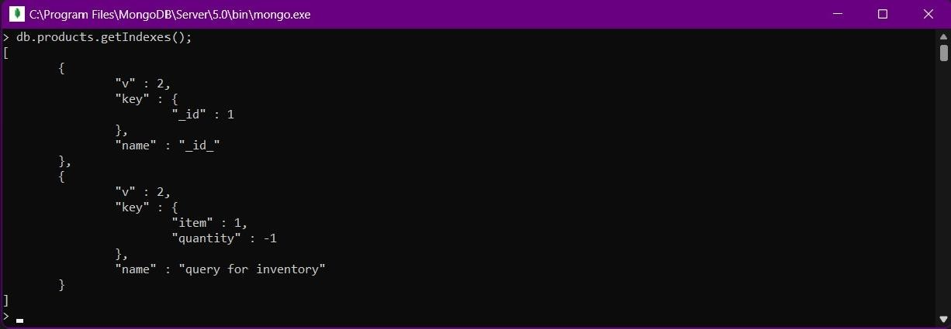

* 1. Drop index by index document

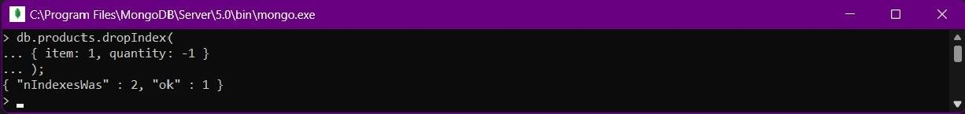

* 1. Insert data

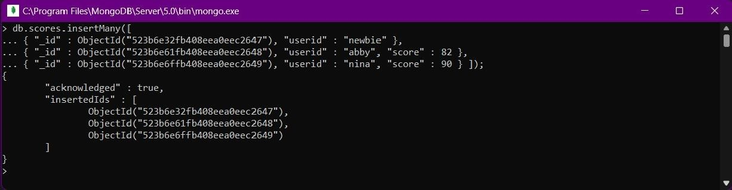

* 1. Create a sparse index

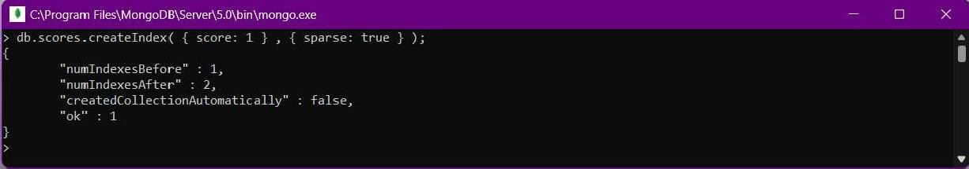

* 1. Use Sparse index on the score field



* 1. Drop all indexes but _id index

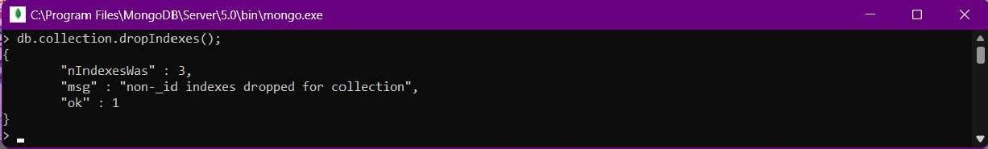

# Result

The program was executed and the result was successfully obtained. Thus CO5 was obtained